Southwestern Iowa Chapter of SHRM

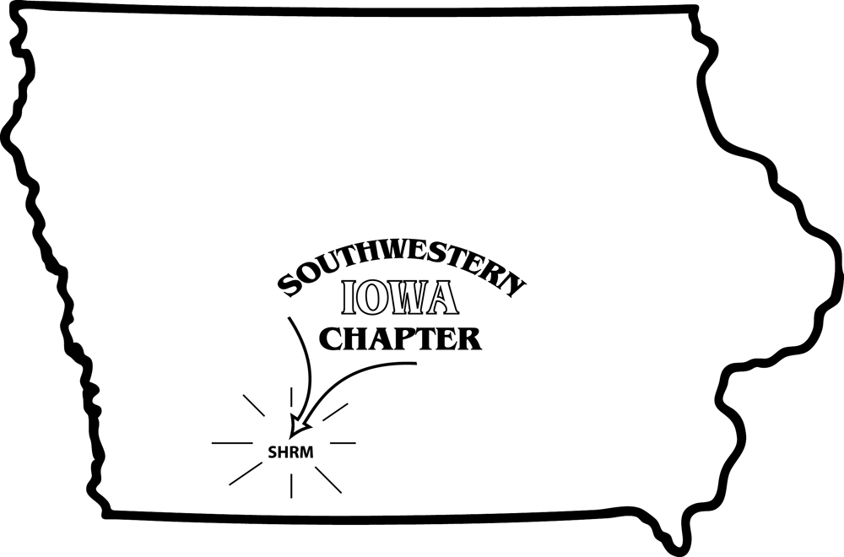

Membership Application

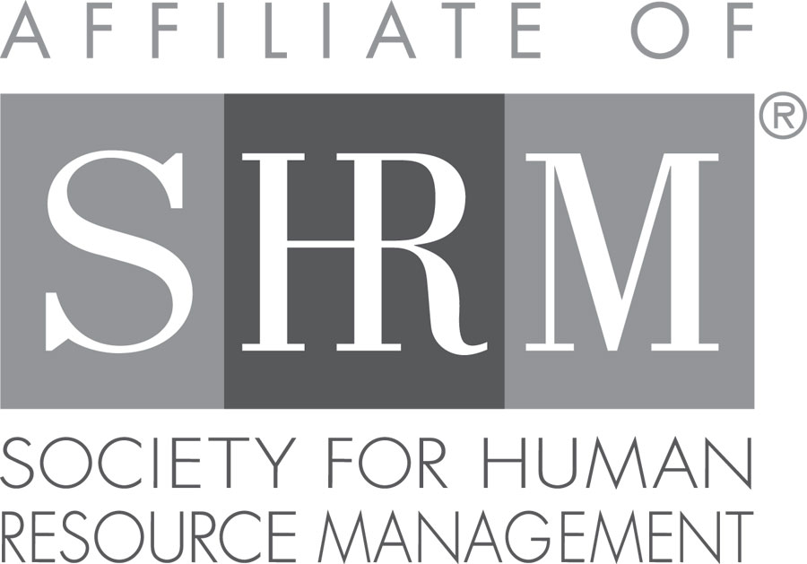

*The primary purpose of the chapter is to provide a forum for learning and exchanging information about current human resources issues. In addition to member discussions at the monthly chapter meetings, we also invite guest speakers who have expertise in various HR topics such as employment law, FLSA, FMLA, ADA, workers compensation, time management, workplace diversity, and OSHA, just to name a few. Members in the chapter have the opportunity to network with other HR professionals and to enrich their professional career in the human resources field.*

National SHRM Membership – Register online @ [www.shrm.org](http://www.shrm.org) ($190/yr)

(Please designate Chapter #567 as your local chapter)

Annual Chapter Membership: $25.00/yr for local membership only

*(January – December)* *Waived* for National SHRM members

*(New membership dues received after September 1 will count toward the following year’s membership.)*

I hereby apply for membership in the Southwestern Iowa Chapter of SHRM and agree to abide by the bylaws of the organization. As a member, I agree to pay the annual membership dues as approved by the Board.

Signature Date

Name (Last, First):

Job Title: Employer:

Work Address: City/State/ZIP:

Work Phone: Work Email:

Home Address: City/State/ZIP:

Home Phone: Cell Phone:

If SHRM member, please indicate member #: Exp. Date:

Certifications: please circle those that apply: PHR SPHR GPHR

Membership Type (please check one): Local Member ($25.00)

SHRM Member (No fee)

Please make check payable to **Southwestern Iowa Chapter of SHRM** and send with completed application form to:

Southwestern Iowa Chapter of SHRM

P.O. Box 205

Creston, Iowa 50801